Function
_____________________________________________________________________________
Function is block of statement which is used for perform some task or function is block of statement which is used for write some logics

Q. Why use function or what is benefit of function?
________________________________________________________________________________
There are two benefits of function
___________________________________________________________________________
1. Reusability: Reusability means we can declare function only once and we can reuse it more than one time.

2. Modularity: Modularity means we can divide the large code in to sub code and integrate them with each other called as modularity

There are two types of function
__________________________________________________________________________
1. Library function: Library function means those function already present in c language or those function provided by c language to us called as library function.
Example: printf(),scanf() etc
2. User defined function: those function define by user for its own purpose called as user defined function.

If we want to work with user define function we have three steps.
1. Declaration: declaration means we specify function name, its return type, its parameter type etc
Called as declaration when we declare function means we specify compiler our function name, its data type, its return type etc

Syntax: return type functionname (datatype, datatype)
Example: void add(int,int); //declaration
2. Definition: Definition means we write actual logic of function called as Definition means if we want to define function we need to write function definition outside of main or any other function and definition must be match with declaration.

If we want to define function we have to know the some important points.
1. Definition must be match with declaration
2. Definition must be outside of main
3. Not need to write semi colon before {opening brace in definition

Syntax of definition
_____________________________________________________________________
return type functionname (data type variablename,datatype variablename){
}

Example:
void add(int x,int y)
{ // write here your logics
}

3. Calling: function calling means when we want to use any function we need to call it.
So if we want to call function we need to know the following important points.

1. Function name must be match with declaration
2. Not need to use data type in calling just we need to know variable name or values.
3. If function return type is void then not need to use variable at left side of function calling
4. When we call function then control jump on function definition for execute the logics

Syntax of function calling
Syntax: functionname (variablename);

Example: we want to create function name as void add(int ,int) and input two values and calculate its addition.

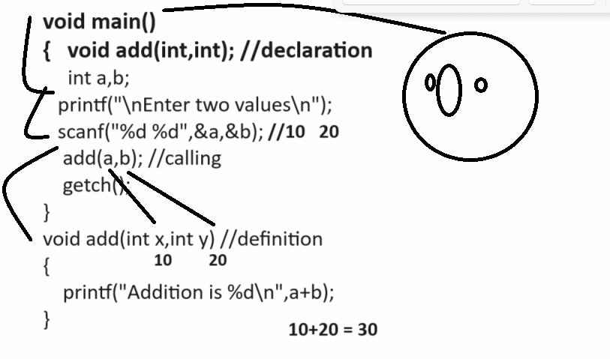
Example:
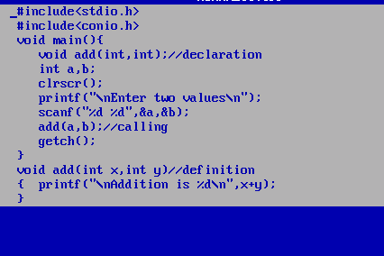

Example: WAP to create function name as void power(int,int) and input two values and calculate its power
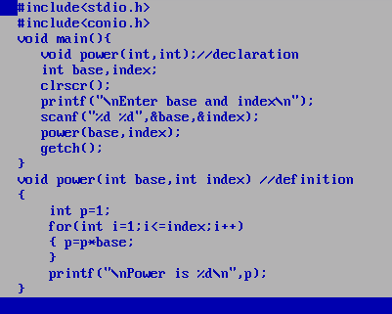

Example: WAP to create function name as void table(int) and input number and print its table.
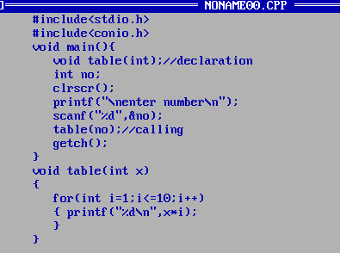

Example: WAP to input number and reverse it using function
void rev(int):
Example: WAP to input number and check number is perfect or not using recursion
void perfect(int);

Example: WAP to input number and check number is prime or not using function
void prime(int)

Example: WAP to input number and check number is Armstrong or not using function
void arm(int);

How to return value from function
______________________________________________________________________________
if we want to return value from function then your function return type should not void
Means when we use void as return type you cannot return value from function means you cannot use return keyword in function definition

Important points with function returning value
1. Function return type should not void
2. Need to use return keyword function definition
3. When function return value need to catch at function calling and for that we required to use
Variable at left hand side of function calling as per the return type of function.

Example: WAP to create function name as square() and accept number as parameter and return its square

int square(int): this function indicate accept integer as input parameter and calculate its square and return it.

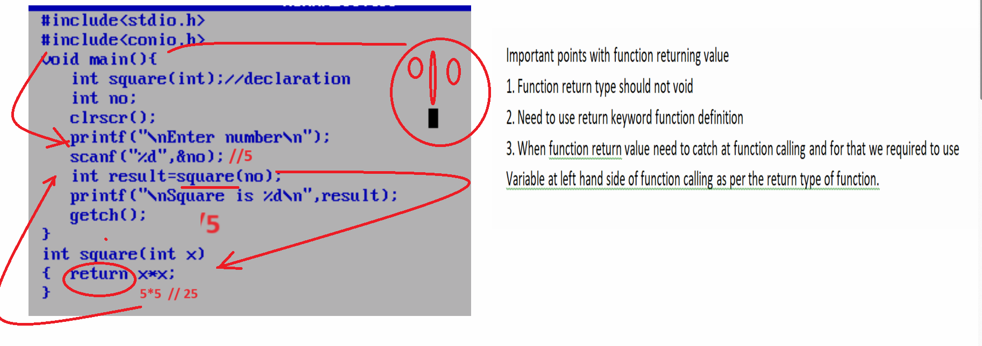

How to pass array as parameter to function
_________________________________________________________________________
If we want to pass array as parameter to the function then we need to pass base address of array as parameter in function from function calling to function definition.
So when we declare function then we can pass pointer as parameter as well as in definition you can pointer as parameter because we pass base address of function form calling point.

Example: we want to create function name as void calSum(int *) and pass array as parameter and display its value in function and calculate the sum of all element of array and display it.
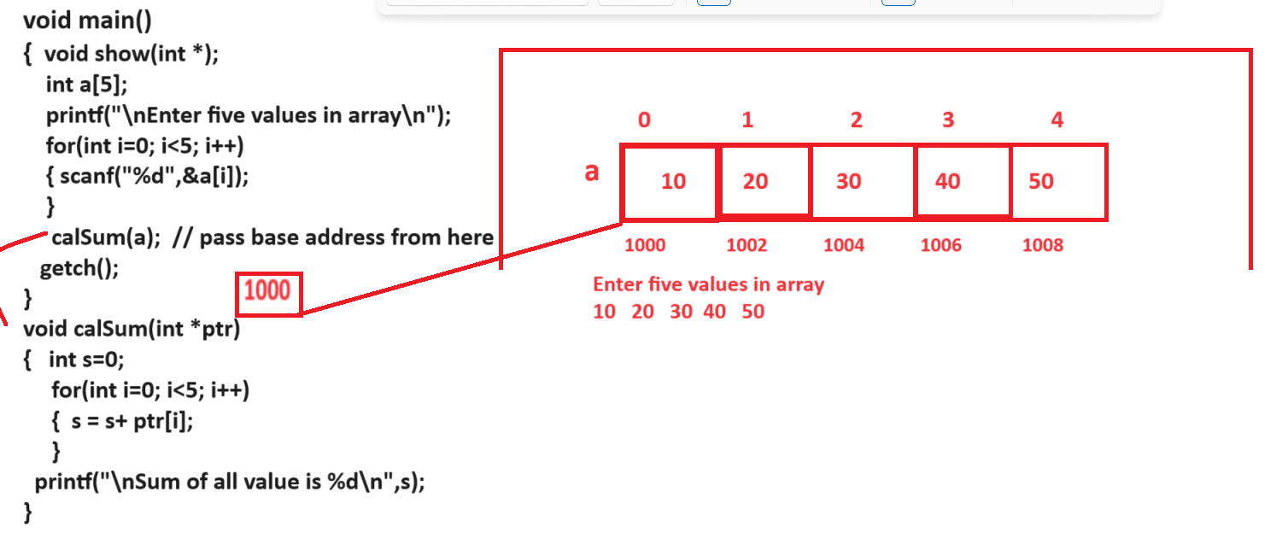

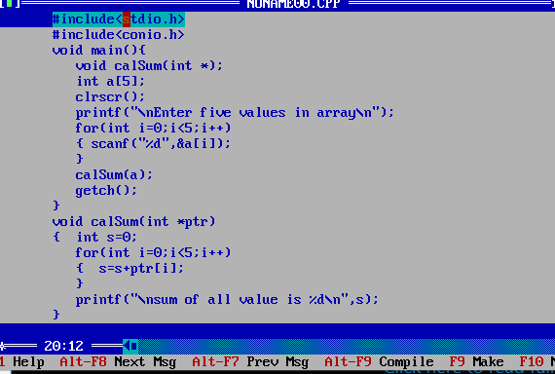

Example: WAP to create function name as int getMax(int *) pass array as parameter and find max alue and return from function.
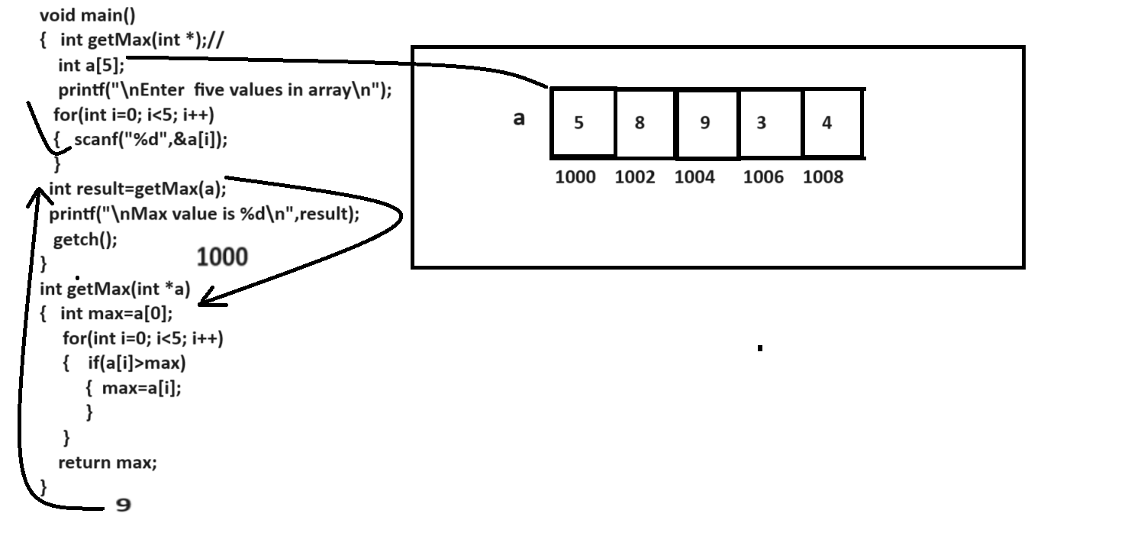

Example: WAP to create function name as int searchValue(int a[],int svalue):
you have to pass two parameter in this function one is array and one is normal parameter and search value in array and return its index if value found in array and if value not found then return -1
if function return -1 then we consider there is no value found
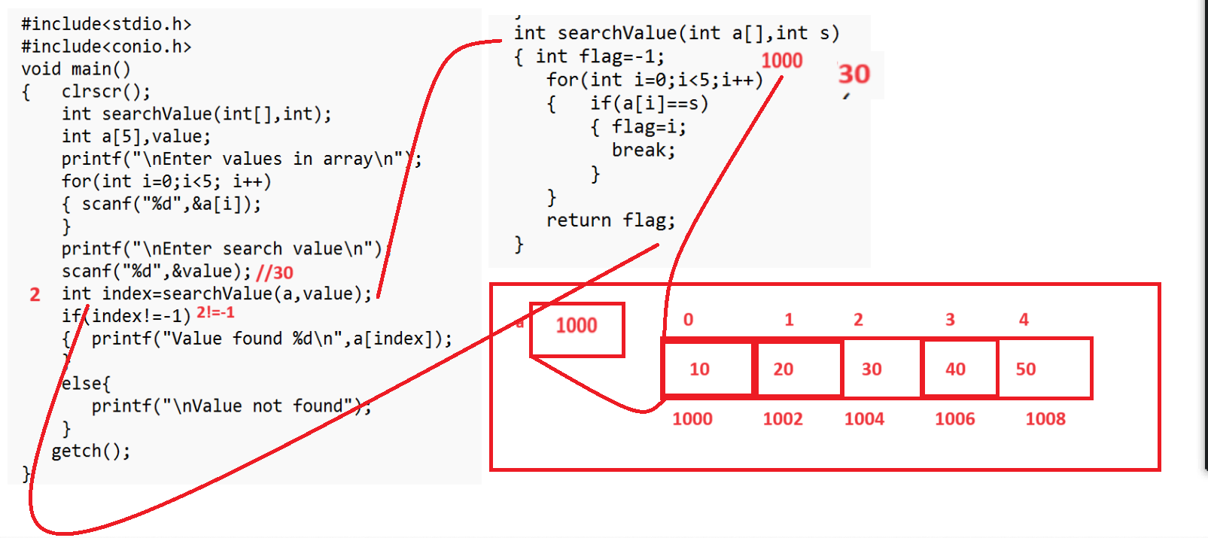

Function Recursion
__________________________________________________________
Function recursion means if function calls itself again and again called as function recursion means in the case of function recursion we call function from its own definition

Generalization syntax of function Recursion is
return type functionname(datatype variablename)
{ if(condition)
{ write here your logics
functioname(datatype) //recursive call
}
}
Example: we want to print good morning 5 times by using a function recursion.

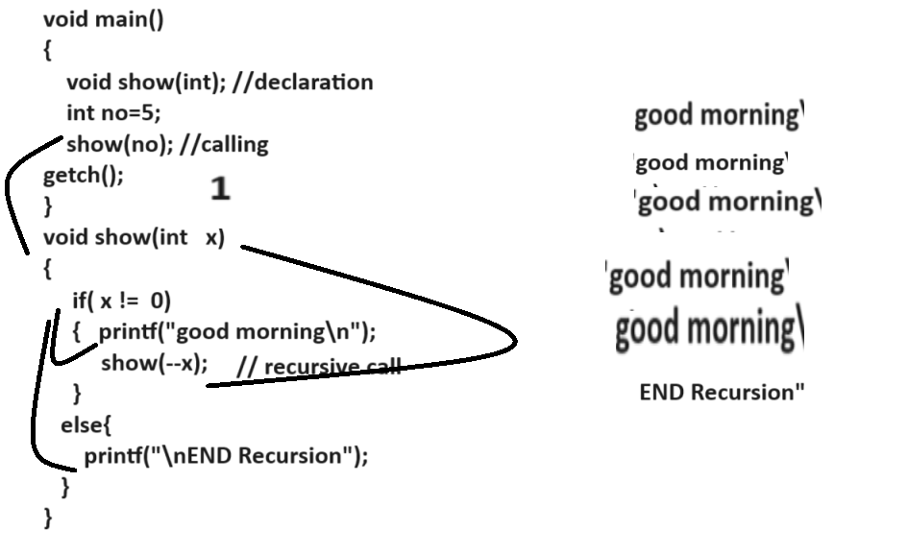
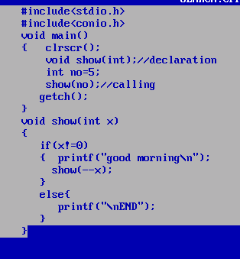

Example: WAP to create function name as void table(int) this function accept number as parameter and print its table using function recursion.
#include<stdio.h>
#include<conio.h>
int count=0;
void main()
{ clrscr();
void show(int);//declaration
int no;
printf("\nEnter number\n");
scanf("%d",&no);
show(no);//calling
getch();
}
void show(int x)
{
if(count!=10)
{ ++count;
printf("%d\n",x*count);
show(x);
}
else{
printf("\nEND");
}
}

